
8th Grade Art Lessons

Lesson: Flower Power (Flowers and Background in Microsoft Paint®)

Objectives:
- Students will learn how to use the various tools in Paint.
- Students learn to use the various layers in Paint along with the copy/paste transparencies.
- Students will demonstrate a knowledge of the use of the tools in Paint.
- Students will create and save a finished flower picture that has a separate background.
- Students will expand and demonstrate their drawing, creative, and technology skills.

Activities:
- The instructor will explain and demonstrate how to use the various tools in Microsoft Paint and do the lesson.
- Students will create and save a single flower in paint using the pencil tool or other tools in Paint.
- Students will open a second Paint and create a background using the various tools in Paint. The background should be finished with color and saved as a separate file.
- Students will copy their flower with a transparent background.
- Students will then paste their flower onto the background.
- Students will paste five other flowers onto the background one at a time, using the stretch and skew along with the rotate tool in Paint to create a finished flower picture.
- Students should save their flower picture and put it on their PowerPoint Portfolios.

Materials: (pencils, paper for practice) Computer with Microsoft Paint and Microsoft PowerPoint, Digital storage, printer, printer ink, paper

Homework: Any unfinished work or work for days absent.

Assessment: 1 to 10 on a 10-point scale for work appropriate to the grade level.
 | Excellent 2 | Great 1.5 | Good 1 | Fair .5 | Poor .25 | Incomplete 0
Fulfillment of Criteria
Overall Appeal
Drawing/Art/Computer Skills
Addition of Color/Shading
Additional Creativity

Standards:1,2,4,5,6,7,8,9,10,11,12,13,14
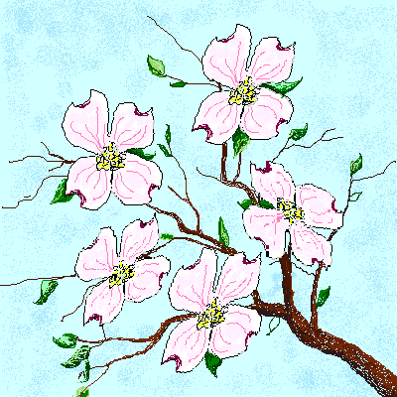
Comments: This will take one or two art sessions.

Leah Morgan, Art Instructor, 2002

